|  |
| --- |
| OpenXML/ODF Translator |
| Install Guide |
| Version 4.0  19 May 2010 |

**Copyright (c) 2006-2009, Clever Age, DIaLOGIKa, Sonata Software Ltd**

All rights reserved.

Redistribution and use in source and binary forms, with or without modification, are permitted provided that the following conditions are met:

* Redistributions of source code must retain the above copyright notice, this list of conditions and the following disclaimer.
* Redistributions in binary form must reproduce the above copyright notice, this list of conditions and the following disclaimer in the documentation and/or other materials provided with the distribution.
* Neither the name of copyright holders, nor the names of its contributors may be used to endorse or promote products derived from this software without specific prior written permission.

THIS SOFTWARE IS PROVIDED BY THE COPYRIGHT HOLDERS AND CONTRIBUTORS “AS IS” AND ANY EXPRESS OR IMPLIED WARRANTIES, INCLUDING, BUT NOT LIMITED TO, THE IMPLIED WARRANTIES OF MERCHANTABILITY AND FITNESS FOR A PARTICULAR PURPOSE ARE DISCLAIMED. IN NO EVENT SHALL CLEVERAGE, DIALOGIKA OR SONATA AND CONTRIBUTORS BE LIABLE FOR ANY DIRECT, INDIRECT, INCIDENTAL, SPECIAL, EXEMPLARY, OR CONSEQUENTIAL DAMAGES (INCLUDING, BUT NOT LIMITED TO, PROCUREMENT OF SUBSTITUTE GOODS OR SERVICES; LOSS OF USE, DATA, OR PROFITS; OR BUSINESS INTERRUPTION) HOWEVER CAUSED AND ON ANY THEORY OF LIABILITY, WHETHER IN CONTRACT, STRICT LIABILITY, OR TORT (INCLUDING NEGLIGENCE OR OTHERWISE) ARISING IN ANY WAY OUT OF THE USE OF THIS SOFTWARE, EVEN IF ADVISED OF THE POSSIBILITY OF SUCH DAMAGE.

Version History

|  |  |  |  |
| --- | --- | --- | --- |
| Version | Date | Author | Change description |
| 1.1 | 07 March 2008 | Alain Zanchetta, Microsoft | Document “Add-in Installation Checklist” created |
|  | 07 March 2007 | DIaLOGIKa & Sonata | Document “Silent Mode Installation Guide” created |
|  | 07 March 2007 | DIaLOGIKa & Sonata | Document “Troubleshooting Guide” created |
| 2.0 | 28 July 2008 | Dirk Vollmar, DIaLOGIKa | Document created based on the documents listed above |
| 2.5.0 | 16 October 2008 | Sonata | Document updated based on the new single installer for all add-ins |
| 2.5.1 | 14 November 2008 | Dirk Vollmar, DIaLOGIKa | Content revised |
| 3.0 | 20 March 2009 | Dirk Vollmar, DIaLOGIKa | Additional troubleshooting info added concerning Windows 2000 and smaller updates |
| 4.0 | 19 May 2010 | Dirk Vollmar, DIaLOGIKa | Additional troubleshooting info added concerning requires Microsoft Office features |

Contents

Introduction 7

Software Requirements 7

Supported applications 7

Additional Requirements 7

.NET Framework 2.0 SP1 7

Office Compatibility Pack 7

Installing ODF Add-in for Microsoft Office 8

Installation Options 8

Selection of Installation Scope 8

Selection of Custom Setup Options 9

Selection of File Associations 10

Usage of ODF Add-in for Microsoft Office 11

ODF-compatible Templates 12

Context Menu 14

Office Security Settings 15

Office 2007 15

Office 2003 16

Command Line Tool 18

Prerequisites 18

.NET Framework 2.0 SP1 18

Installation 18

Usage of the Command Line Tool 18

Silent Installation 19

Prerequisites 19

.NET Framework 2.0 19

Application-Specific Downloads 19

OpenXML/ODF Translator Add-In 19

Installation 19

Uninstallation 20

Other options available for silent installation 21

Interaction Modes 21

Log File 21

Feature Selection 21

Troubleshooting 22

Files installed 23

Add/Remove program entries 24

All Office Versions: 24

Office 2000/XP/2003: 24

Requires Microsoft Office Features 25

Registry entries 26

ODF Add-in for Microsoft Word 26

ODF Add-in for Microsoft Excel 27

ODF Add-in for Microsoft PowerPoint 28

Windows Vista complement 30

Additional Troubleshooting Steps 31

Step 1: Check that only one version of the translator is installed 31

Step 2: Check Office configuration 31

Step 3: Check that the pre-requisites are installed 36

.NET Framework 2.0 SP1 36

Compatibility Pack for the 2007 Office System 37

KB908002 37

# Introduction

This document describes in detail the installation of the OpenXML/ODF Translator add-in for Microsoft Office.

# Software Requirements

## Supported applications

The following Microsoft Office versions are supported by the OpenXML/ODF Translator:

* Microsoft Office 2000 (Word only)
* Microsoft Office XP
* Microsoft Office 2003
* Microsoft Office 2007

## Additional Requirements

### .NET Framework 2.0 SP1

The OpenXML/ODF Translator is based on .NET technology. Therefore .NET Framework 2.0 must be installed on the target machine. A redistributable package is available for download at

<http://www.microsoft.com/downloads/details.aspx?familyid=0856eacb-4362-4b0d-8edd-aab15c5e04f5>

After the installation of the OpenXML/ODF Translator add-in please update your installation of the .NET Framework with the latest service pack available from Windows update.

**Note**: .NET Framework 2.0 will be downloaded and installed automatically by the setup program if it is not yet installed. Please note that this requires an internet connection.

### Office Compatibility Pack

If the add-in is used with an Office version earlier than Office 2007, the Office Compatibility Pack must be installed. The latest version of the Office Compatibility Pack can be downloaded from

<http://www.microsoft.com/downloads/details.aspx?FamilyID=941b3470-3ae9-4aee-8f43-c6bb74cd1466>

**Note**: Office Compatibility Pack will be downloaded and installed automatically by the setup program if it is not yet installed. Please note that this requires an internet connection.

Please also update the installation of the Compatibility Pack with the latest service pack available at <http://www.microsoft.com/DownLoads/details.aspx?familyid=9A1822C5-49C6-47BD-8BEC-0D68693CA564>

**Important**: Make sure you have the latest **service packs** and **critical updates** for the version of Windows and Office that you are running.

Users of Windows 2000 also will have to install [Update Rollup 1 for Windows 2000 SP4 (KB891861)](http://www.microsoft.com/downloads/details.aspx?FamilyID=b54730cf-8850-4531-b52b-bf28b324c662)

Installation on a machine which is not running the latest updates might fail or result in poor performance.

# Installing ODF Add-in for Microsoft Office

Download the latest version of the ODF Add-in for Microsoft Office installer from the project’s download page on SourceForge:

<https://sourceforge.net/project/showfiles.php?group_id=169337>

Localized versions of the add-in are currently available in these languages:

* Chinese
* Dutch
* English
* French
* German
* Japanese
* Polish

**Important**: Installing the add-in as Administrator is the recommended way.

Non-administrative installation will only work for the current user and will not offer the best run-time performance possible.

To start the installation, please double click the self-extracting installation file, e.g. “OdfAddInForOfficeSetup-en.exe” if you downloaded the English localization, and then follow the instructions on the screen.

Note: This is a single installer for Word, Excel and PowerPoint add-ins. The user has the option of selecting which of the add-ins will be installed during setup.

## Installation Options

### Selection of Installation Scope

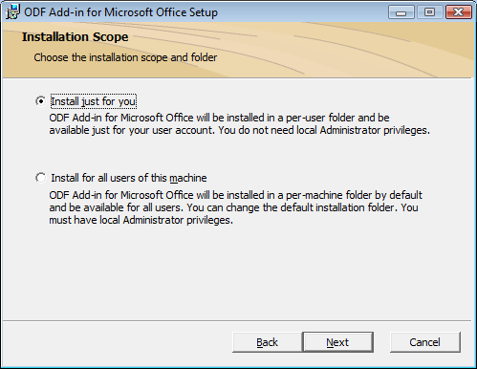

ODF Add-in for Microsoft Office can be installed either for the current user or for all users of a machine. Please note that installing for all users requires administrative privileges on the machine.

### Selection of Custom Setup Options

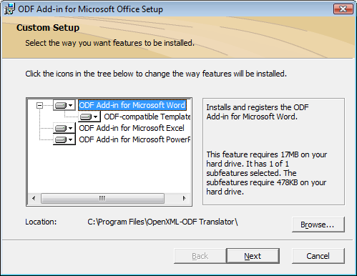

The following wizard page allows you to specify a custom installation folder and to select which features of ODF Add-in for Microsoft Office should be installed. For example, you may choose to install the add-in only for Word.

Per default, also a set of ODF-compatible Word document templates will be installed which have been especially designed using only features available in both ODF and OpenXML. Thus, documents based on these templates can be converted between the two formats with high fidelity.

Note: The ODF-compatible templates are only installed for the current user. To deploy the templates to more than one user run the setup with the option “Install just for you” for each of these users.

### Selection of File Associations

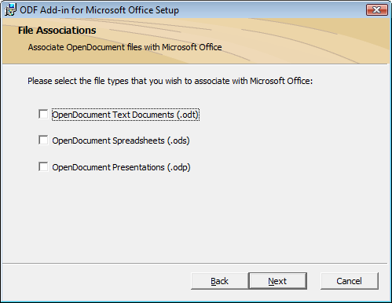

On the following screen you may choose to associate OpenDocument files with Microsoft Office. This option is intended for users which do not yet have an application supporting OpenDocument Format installed on their PC. Installing the file associations allows you to open.odt, .ods or .odp files with the respective Microsoft Office application.

Please note that you can always change this behavior later using Windows Explorer via the “Open With…” entry in the context menu of ODF files.

## Usage of ODF Add-in for Microsoft Office

If the installation has been completed successfully, you should be able to open and save documents in OpenDocument Format (.odt, .ods and .odp files) from Microsoft Office using the new ODF menu commands shown below:

|  |  |
| --- | --- |
| Office 2007 |  |
| Other versions of Office |  |

## ODF-compatible Templates

Included with version 2.5 of the ODF Add-in for Microsoft Office is a set of Word templates especially designed for interoperability with the OpenDocument Format. These templates are installed by the setup program and can be access from the Word user interface by the menu commands shown below. Please note that the additional menu option “New Document” in Word 2007 only appears if the ODF-compatible Templates have been selected during setup.

|  |  |
| --- | --- |
| Office 2007 |  |
| Other versions of Office | Please click on File 🡪 New to open the *New Document* task pane:    Clicking the *On My Computer* link will open the *Templates* dialog: |

## Context Menu

When right-clicking on an OpenDocument file in Windows Explorer, a menu entry to open the document in the respective Microsoft Office application is shown, e.g. the entry “Open with Microsoft Word” is shown for .odt files:

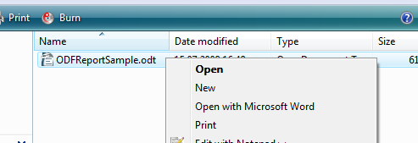

**Note**: The OpenDocument file opened by the add-in is imported in Microsoft Office as a read-only document. If you want to save it as ODF, you will have to first make a copy of the document(Office Menu -> Save As) and then use the “Save as ODF” menu command.

# Office Security Settings

ODF Add-in for Microsoft Office is provided as a signed add-in. This means that the add-in can be configured to load even with the Office add-in security level set to high.

## Office 2007

The security settings for add-ins can be configured in the Trust Center available via Office Menu -> Word / Excel /PowerPoint Options -> Trust Center -> Trust Center Settings…

With the settings as shown below only add-ins signed by a trusted publisher will be loaded into Office:

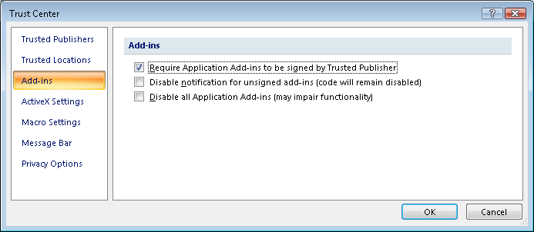

If the publisher (i.e. DIaLOGIKa or Sonata) are not added to the list of trusted publishers yet, the following security warning will be shown:



Clicking on *Options…* will open the following dialog:



To permanently add the add-in to the Office application, please choose the third option *Enable all code published by this publisher*. This will add the publisher (i.e. DIaLOGIKa GmbH or Sonata Software Ltd) to the list of *Trusted Publishers*.

## Office 2003

The security settings for add-ins can be configured via Tools -> Macro -> Security… With the settings as shown below only add-ins signed by a trusted publisher will be loaded into Office:



If the publisher (i.e. DIaLOGIKa GmbH or Sonata Software Ltd) are not added to the list of trusted publishers yet, the following security warning will be shown:



Select the option *Always trust macros from this publisher* to permanently add the add-in to the Office application. This will add the publisher (i.e. DIaLOGIKa or Sonata) to the list of *Trusted Publishers*.

Then click on *Enable Macros* to continue.

# Command Line Tool

## Prerequisites

### .NET Framework 2.0 SP1

Download and install the **Microsoft .NET Framework 2.0 Redistributable Package** available at

<http://www.microsoft.com/downloads/details.aspx?FamilyID=0856EACB-4362-4B0D-8EDD-AAB15C5E04F5&displaylang=en>).

**Important**: After installing .NET Framework 2.0 visit Windows Update to install Service Pack 1 for .NET Framework 2.0 and all other critical patches.

## Installation

Download the latest version of the **OpenXML/ODF Translator** **Command Line Tool** from the project’s download page on SourceForge:

<https://sourceforge.net/project/showfiles.php?group_id=169337>

To install the OpenXML/ODF Translator Command Line Tool simply extract the zip archive to a folder of your choice on your local hard drive.

**Note:** You can significantly speed up performance of the command line tool by running the following command as an administrator (<path> should be the directory where the command line tool has been extracted to):

**cd <path>**

**for %F in (*.dll) do %WINDIR%\Microsoft.NET\Framework\v2.0.50727\ngen.exe “%F”**

## Usage of the Command Line Tool

To display a list of all available options simply call the command line tool without any parameters:

**OdfConverter.exe**

The options available in version 2.5 are:

**Usage: OdfConverter.exe /I PathOrFilename [/O PathOrFilename] [/<OPTIONS>]**

**Where options are:  
 /I PathOrFilename Name of the file to transform (or input folder in case of batch conversion)  
 /O PathOrFilename Name of the output file (or output folder)  
 /F Overwrite existing file(s)  
 /V Validate the result of the transformation against the schemas  
 /P Show conversion progress on the command line  
 /REPORT Filename Name of the report file that should be generated   
 /LEVEL Level Level of reporting: 1=DEBUG, 2=INFO, 3=WARNING, 4=ERROR  
  
 Batch options (use one of the /BATCH-<format> options at a time):  
 /BATCH-ODT Do a batch conversion over every ODT file in the input folder   
 /BATCH-DOCX Do a batch conversion over every DOCX file in the input folder  
 /BATCH-ODP Do a batch conversion over every ODP file in the input folder   
 /BATCH-PPTX Do a batch conversion over every PPTX file in the input folder  
 /BATCH-ODS Do a batch conversion over every ODS file in the input folder   
 /BATCH-XLSX Do a batch conversion over every XLSX file in the input folder  
 /R Process subfolders recursively during batch conversion  
  
 Conversion direction options (to disable automatic file type detection):  
 /ODT2DOCX Force conversion to DOCX regardless of input file extension  
 /DOCX2ODT Force conversion to ODT regardless of input file extension  
 /ODS2XLSX Force conversion to XLSX regardless of input file extension  
 /XLSX2ODS Force conversion to ODS regardless of input file extension  
 /ODP2PPTX Force conversion to PPTX regardless of input file extension  
 /PPTX2ODP Force conversion to ODP regardless of input file extension  
 Developer options:  
 /XSLT Path Path to a folder containing XSLT files   
 /NOPACKAGING Don't package the result of the transformation into a ZIP archive   
 /SKIP Name Skip a post-processing (provide the post-processor's name)**

# Silent Installation

This section describes the silent mode installation for the OpenXML/ODF Translator Add-In for Microsoft Office. The following Office applications and versions are supported:

* Word: 2000, XP, 2003 and 2007
* Excel: XP, 2003 and 2007
* PowerPoint: XP, 2003 and 2007

## Prerequisites

### .NET Framework 2.0

Download and install the Microsoft .NET **Framework 2.0 Redistributable Package** available at

<http://www.microsoft.com/downloads/details.aspx?FamilyID=0856EACB-4362-4B0D-8EDD-AAB15C5E04F5&displaylang=en>).

**Important**: After installing .NET Framework 2.0 visit Windows Update to install Service Pack 1 for .NET Framework 2.0 and all other critical patches.

### Application-Specific Downloads

#### Office 2000, XP or 2003

If you are installing the OpenXML/ODF Translator Add-In for Microsoft Office 2000, XP or 2003 download and install **Microsoft Office Compatibility Pack for 2007 File Formats** available at

<http://www.microsoft.com/downloads/details.aspx?displaylang=en&FamilyID=941b3470-3ae9-4aee-8f43-c6bb74cd1466>).

**Note:** Please also update the installation of the Compatibility Pack with the latest service pack available at <http://www.microsoft.com/DownLoads/details.aspx?familyid=9A1822C5-49C6-47BD-8BEC-0D68693CA564>

## OpenXML/ODF Translator Add-In

Download the **OpenXML/ODF Translator Add-In for Microsoft Office** from

<https://sourceforge.net/project/showfiles.php?group_id=169337>

**Important:** Silent installation must be done with administrative privileges. In Windows Vista, please make sure that all commands are executed with an elevated token, e.g. by running an installation script from an elevated command prompt window.

|  |  |
| --- | --- |
| Installation | |
| ***Step 1*** | Extract the executable file to a location of your choice using the following parameters (*<path>* is the location where the extracted installation files are stored, e.g. *c:\SilentInst\)*.  *<xx>* is the language code of the Add-In, e.g. ‘en’ for the English version or ‘de’ for the German version):  OdfAddInForOfficeSetup-<xx>.exe /C /T:<path>  After you have extracted the installation files, navigate to the extraction folder, for example:  cd C:\Translator\SilentInst\  Example (assuming an installation of a Dutch add-in):  OdfAddInForOfficeSetup-nl.exe /C /T:C:\SilentInst\  cd C:\SilentInst\ |
| ***Step 2*** | **Note:** This step can be skipped for Word, Excel and/or PowerPoint 2007  Install the shared add-in extensibility update for Microsoft .NET Framework 2.0 (KB908002, more information at <http://support.microsoft.com/kb/908002>):  msiexec /i extensibilityMSM.msi /q  msiexec /i \KB908002\lockbackRegKey.msi /q |
| ***Step 3*** | Install the add-in using one of the following commands (depending on the add-in version you are using). *<xx>* is the language code of the Add-In, e.g. ‘en’ for the English version or ‘de’ for the German version, etc.  For All Users:  msiexec /i OdfAddInForOfficeSetup-<xx>.msi /q ALLUSERS=1  or  For Single User:  msiexec /i OdfAddInForOfficeSetup-<xx>.msi /q |
| ***Step 4*** | **Note:** This step is only required for Word 2003, Excel 2003 and PowerPoint 2003.  Install the executable for Office 2003 (more information can be found at <http://support.microsoft.com/kb/907417>):  **office2003-kb907417sfxcab-ENU.exe /quiet** |
| ***Step 5*** | Finally, check that the installation is finished before launching Word, Excel or PowerPoint. |

|  |  |
| --- | --- |
| Uninstallation | |
|  | Please make sure that all the installation files are extracted to the specified folder and that you call the following command from this folder as described in *Step 1* above. Uninstall the add-in using one of the following commands (depending on the add-in version you are using). *<xx>* is the language code of the Add-In, e.g. ‘en’ for the English version or ‘de’ for the German version, etc.  Please note that the **ALLUSERS** parameter should only be specified if it has been set during installation (step 3 above).  msiexec /x OdfAddInForOfficeSetup-<xx>.msi /q ALLUSERS=1 |

## Other options available for silent installation

The following are the other parameters that can be used in place of /q for different types of installation.

### Interaction Modes

|  |  |  |
| --- | --- | --- |
| **Parameter** | **Name** | **Description and Command** |
| /qf | Full UI | While installing an UI screen appears and ask for the user input, e.g.  msiexec /x OdfAddInForOfficeSetup-<xx>.msi /qf ALLUSERS=1 |
| /qr | Reduced UI | While installing UI screen appears but does not ask for any further user input, e.g.  msiexec /x OdfAddInForOfficeSetup-<xx>.msi /qr ALLUSERS=1 |
| /qb | Basic UI | While installing UI screen appears only with Progress window, e.g.  msiexec /x OdfAddInForOfficeSetup-<xx>.msi /qb ALLUSERS=1 |

### Log File

To create a verbose log add the option */l*vx <logfile>* to the call of msiexec, e.g.

**msiexec /i OdfAddinForOfficeSetup.msi /q /l*vx log.txt**

### Feature Selection

The optional MSI property **ADDLOCAL** is a comma-separated list of the features to be installed. The following feature names can be used:

* WORDADDIN to install the add-in for Word
* TEMPLATES to install the ODF-compatible Word templates
* EXCELADDIN to install the add-in for Excel
* POWERPOINTADDIN to install the add-in for PowerPoint

If the property ADDLOCAL is omitted, the default set of features (i.e. all features of ODF Add-in for Microsoft Office) will be installed.

#### Example Full installation:

**msiexec /i OdfAddinForOfficeSetup.msi /q ADDLOCAL=WORDADDIN, TEMPLATES, EXCELADDIN, POWERPOINTADDIN**

#### Example: Installing Word add-in and ODF-compatible templates

**msiexec /i OdfAddinForOfficeSetup.msi /q ADDLOCAL=WORDADDIN, TEMPLATES**

# Troubleshooting

Even if the ODF Add-in for Microsoft Office has been thoroughly tested under a large number of configurations, there may be circumstances where the add-in did not install successfully. This might be indicated by

* ODF Options are missing from Office menus, or
* ODF converter is not launched when the menu options are selected.

For each add-in, this section presents the list of the **files**, the **registry entries** as well as the **add/remove programs** entries which are needed to run the add-in. In addition to these items, it is also mandatory that every Office installation is up to date, i.e. has not only the **latest service pack** but also the **latest fixes**.

After a successful installation, the ODF Add-in for Microsoft Office should add new menu entries to the Office applications’ *File* menu to allow the user to import and export ODF documents from within Office. Table 1 shows these menu entries for the different versions of Word, PowerPoint and Excel.

If these menu entries appear, then it is most likely that the Translator will work. If the conversion of a document fails, it is most likely that the failure is related to currently unsupported features used in that specific document.

Therefore, this document focuses on the diagnostic of missing ODF menu entries.

|  |  |
| --- | --- |
| Office 2007 |  |
| Other versions of Office |  |

Table : ODF Add-in for Microsoft Office menu entries

## Files installed

If files presented in this document are missing from the installation folder, it is most likely that the setup procedure has been corrupted.

If additional files are present in the installation directory, it may be the result of an older installation. In this case, the best thing to do is to uninstall all versions of the add-in from Add/Remove programs applet, clean the installation folder and reinstall the add-in.

The following files should be present in the installation folder, e.g. C:\Program Files\OpenXML-ODF Translator per default:

* OdfAddinLib.dll
* OdfConverter.exe
* OdfConverterLauncher.exe
* OdfConverterLib.dll
* OdfExcelAddin.dll
* OdfExcelAddinShim.dll
* OdfPowerPointAddin.dll
* OdfPowerPointAddinShim.dll
* OdfWordAddin.dll
* OdfWordAddinShim.dll
* OdfZipUtils.dll
* PresentationConverter.dll
* PresentationConverter2Odf.dll
* PresentationConverter2Oox.dll
* Readme.html
* SpreadsheetConverter.dll
* SpreadsheetConverter2Odf.dll
* SpreadsheetConverter2Oox.dll
* WordprocessingConverter.dll
* WordprocessingConverter2Odf.dll
* WordprocessingConverter2Oox.dll
* zlibwapi.dll
* de-DE\OdfAddinLib.resources.dll
* de-DE\OdfExcelAddin.resources.dll
* de-DE\OdfPowerPointAddin.resources.dll
* de-DE\OdfWordAddin.resources.dll
* fr-FR\OdfAddinLib.resources.dll
* fr-FR\OdfExcelAddin.resources.dll
* fr-FR\OdfPowerPointAddin.resources.dll
* fr-FR\OdfWordAddin.resources.dll
* ja-JP\OdfAddinLib.resources.dll
* ja-JP\ OdfExcelAddin.resources.dll
* ja-JP\ OdfPowerPointAddin.resources.dll
* ja-JP\OdfWordAddin.resources.dll
* nl-NL\OdfAddinLib.resources.dll
* nl-NL\ OdfExcelAddin.resources.dll
* nl-NL\ OdfPowerPointAddin.resources.dll
* nl-NL\OdfWordAddin.resources.dll
* pl-PL\OdfAddinLib.resources.dll
* pl-PL\ OdfExcelAddin.resources.dll
* pl-PL\ OdfPowerPointAddin.resources.dll
* pl-PL\OdfWordAddin.resources.dll
* zh-CHS\OdfAddinLib.resources.dll
* zh-CHS\ OdfExcelAddin.resources.dll
* zh-CHS\ OdfPowerPointAddin.resources.dll
* zh-CHS\OdfWordAddin.resources.dll

If the ODF-compatible templates have been installed, also the following files should be present:

* Templates\ ODFFax.png
* Templates\ ODFFaxBig.png
* Templates\ ODFLetter.png
* Templates\ ODFLetterBig.png
* Templates\ ODFMemo.png
* Templates\ ODFMemoBig.png
* Templates\ ODFReport.png
* Templates\ ODFReportBig.png
* Templates\ templates.xml

## Add/Remove program entries

Basically, the only thing to check here is the presence of the two entries related to **KB908002** for Office XP and Office 2003 Add-ins. If these entries are not present, the add-in will fail to load.

### All Office Versions:

* Microsoft .NET Framework 2.0 Service Pack 1 (is not listed on Vista)

### Office 2000/XP/2003:

* Compatibility Pack for the 2007 Office System (is not listed for Office 2007)
* Shared Add-in Extensibility Update for the Microsoft .NET Framework 2.0 (KB908002)
* Shared Add-in Support Update for the Microsoft .NET Framework 2.0 (KB908002)

## Requires Microsoft Office Features

In order to work correctly, ODF Add-in for Microsoft Office requires that certain Office features have been installed. Please make sure that the following features are present:

* *.NET Programmability Support* needs to be installed for Word, Excel and PowerPoint:  
    
  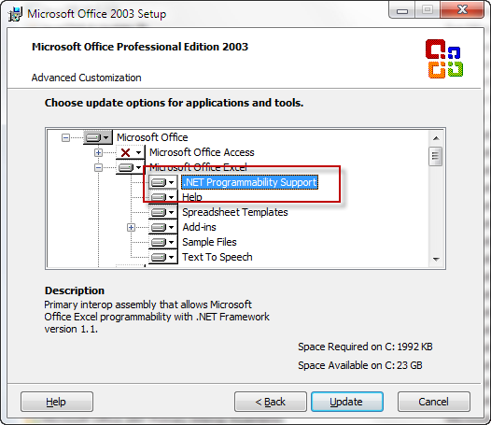
* *Visual Basic for Application* needs to be selected under *Office Shared Features*:  
    
  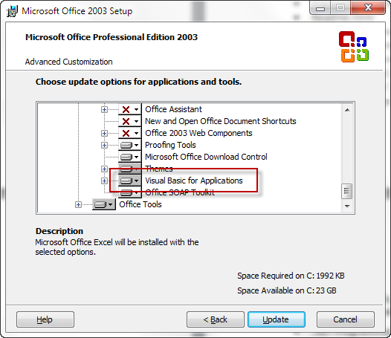

## Registry entries

If the registry entries presented in this document are not present on the target machine, the add-in will not work. The real entries may differ from what is presented here in two ways only:

* the path of the files if the installation folder is not the same than on the machine I used for this document,
* the version of the Add-In DLLs which will evolve with time.

**Note**: In all add-in descriptions, there are entries under

**HKEY_LOCAL_MACHINE\CLSID\{TheGuidOfTheAdd-in}**

If there are additional entries under this kind of key (i.e. other entries than described in this section), for example additional versions of the add-in, these additional entries must be deleted.

### ODF Add-in for Microsoft Word

#### Component registration as Word Add-in

When installed “per-user”:

[HKEY_CURRENT_USER\Software\Microsoft\Office\Word\Addins\OdfWordAddin.Connect]

"LoadBehavior"=dword:00000003

"Description"="Version 2.5.4980.0"

"FriendlyName"="ODF Add-in for Office"

Or, when installed “per-machine”

[HKEY_LOCAL_MACHINE\Software\Microsoft\Office\Word\Addins\OdfWordAddin.Connect]

"LoadBehavior"=dword:00000003

"Description"="Version 2.5.4980.0"

"FriendlyName"="ODF Add-in for Office"

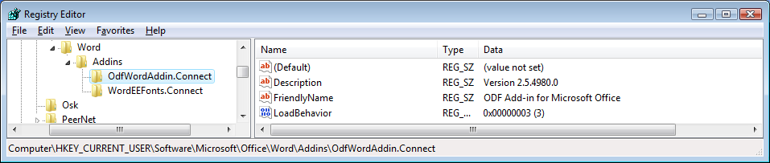

#### Add-in Registration as COM Component

The following entries must be present to register the add-in as a COM component:

[HKEY_CLASSES_ROOT\OdfWordAddin.Connect]

[HKEY_CLASSES_ROOT\OdfWordAddin.Connect\CLSID]

@="{f474d30d-3450-423e-ae62-bd3307544e86}"

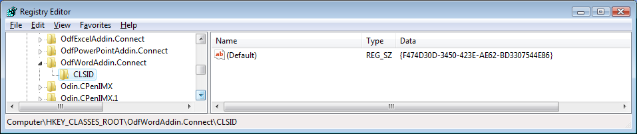

[HKEY_CLASSES_ROOT\CLSID\{f474d30d-3450-423e-ae62-bd3307544e86}]  
@="OdfWordAddin.Connect"

[HKEY_CLASSES_ROOT\CLSID\{f474d30d-3450-423e-ae62-bd3307544e86}\InProcServer32]  
@="C:\\Program Files\\OpenXML-ODF Translator\\OdfWordAddinShim.dll"

"ThreadingModel"="Apartment"

[HKEY_CLASSES_ROOT\CLSID\{f474d30d-3450-423e-ae62-bd3307544e86}\ProgId]

@="OdfWordAddin.Connect"

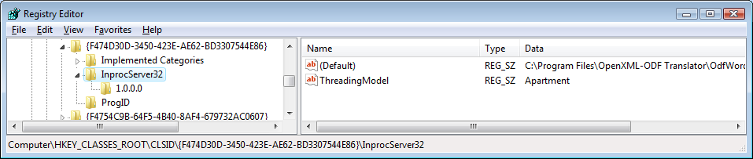

**ONLY ONE VERSION**

#### Add-in Options

Add-in options are stored under the following key when installed “per-user”:

[HKEY_CURRENT_USER\Software\OpenXML-ODF Translator\ODF Add-in for Word}

When installed “per-machine”

[HKEY_CURRENT_USER\Software\OpenXML-ODF Translator\ODF Add-in for Word}

[HKEY_LOCAL_MACHINE\Software\OpenXML-ODF Translator\ODF Add-in for Word}

### ODF Add-in for Microsoft Excel

#### Component registration as Excel Add-in

When installed “per-user”:

[HKEY_CURRENT_USER\Software\Microsoft\Office\Excel\Addins\OdfExcelAddin.Connect]

"LoadBehavior"=dword:00000003

"Description"="Version 2.5.4980.0"

"FriendlyName"="ODF Add-in for Office"

Or, when installed “per-machine”

[HKEY_LOCAL_MACHINE\Software\Microsoft\Office\Excel\Addins\OdfExcelAddin.Connect]

"LoadBehavior"=dword:00000003

"Description"="Version 2.5.4980.0"

"FriendlyName"="ODF Add-in for Office"

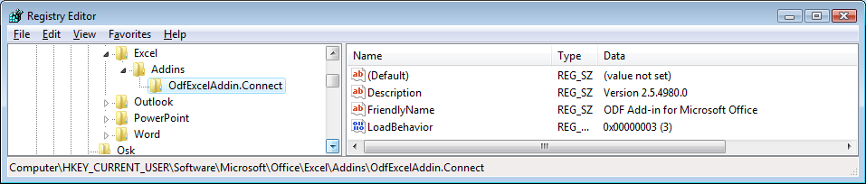

#### Add-in Registration as COM Component

[HKEY_CLASSES_ROOT\OdfExcelAddin.Connect]

@="OdfConverter.Spreadsheet.OdfExcelAddin.Connect"

[HKEY_CLASSES_ROOT\OdfExcelAddin.Connect\CLSID]

@="{e00c9ebb-f140-4e6f-8c7b-eed19ae33aea}"

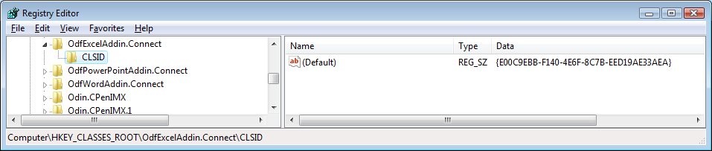

[HKEY_CLASSES_ROOT\CLSID\{E00C9EBB-F140-4E6F-8C7B-EED19AE33AEA}]  
@="OdfExcelAddin.Connect"

[HKEY_CLASSES_ROOT\CLSID\{E00C9EBB-F140-4E6F-8C7B-EED19AE33AEA}\InProcServer32]

@=" C:\\Program Files\\OpenXML-ODF Translator\\\\OdfExcelAddinShim.dll"

"ThreadingModel"="Apartment"

[HKEY_CLASSES_ROOT\CLSID\{E00C9EBB-F140-4E6F-8C7B-EED19AE33AEA}\ProgId]

@="OdfExcelAddin.Connect"

"(Default)"="OdfExcelAddin.Connect"

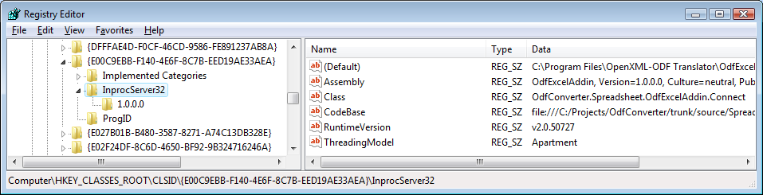

**ONLY ONE VERSION**

#### Add-in Options

Add-in options are stored under the following key when installed “per-user”:

[HKEY_CURRENT_USER\Software\OpenXML-ODF Translator\ODF Add-in for Excel}

When installed “per-machine”

[HKEY_CURRENT_USER\Software\OpenXML-ODF Translator\ODF Add-in for Excel}

[HKEY_LOCAL_MACHINE\Software\OpenXML-ODF Translator\ODF Add-in for Excel}

### ODF Add-in for Microsoft PowerPoint

#### Component registration as PowerPoint Add-in

When installed “per-user”:

[HKEY_CURRENT_USER\Software\Microsoft\Office\PowerPoint\Addins\OdfPowerPointAddin.Connect]

"LoadBehavior"=dword:00000003

"Description"="Version 2.5.4980.0"

"FriendlyName"="ODF Add-in for Office"

Or, when installed “per-machine”

[HKEY_LOCAL_MACHINE\Software\Microsoft\Office\PowerPoint\Addins\OdfPowerPointAddin.Connect]

"LoadBehavior"=dword:00000003

"Description"="Version 2.5.4980.0"

"FriendlyName"="ODF Add-in for Office"

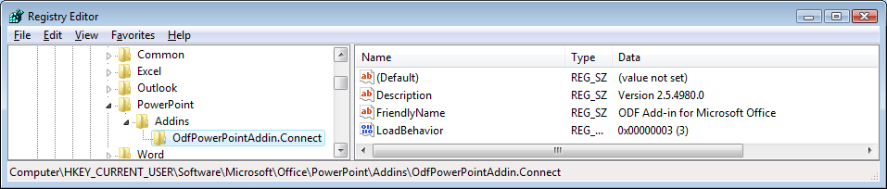

#### Add-in Registration as COM Component

The following entries must be present to register the add-in as a COM component:

[HKEY_CLASSES_ROOT\OdfPowerPointAddin.Connect]

[HKEY_CLASSES_ROOT\OdfPowerPointAddin.Connect\CLSID]

@="{7F459B4C-65F0-4D44-BB27-66C5FD3CA151}"

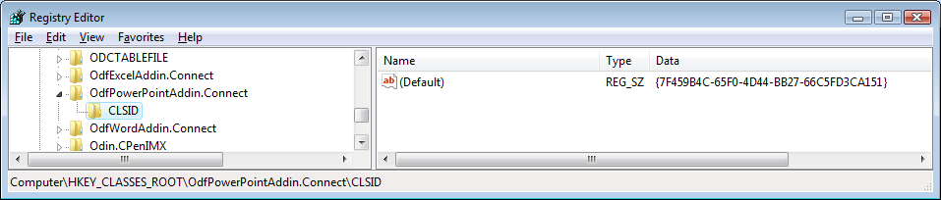

[HKEY_CLASSES_ROOT\CLSID\{7F459B4C-65F0-4D44-BB27-66C5FD3CA151}]  
@="OdfPowerPointAddin.Connect"

[HKEY_CLASSES_ROOT\CLSID\{7F459B4C-65F0-4D44-BB27-66C5FD3CA151}\InProcServer32]  
@="C:\\Program Files\\OpenXML-ODF Translator\\OdfPowerPointAddinShim.dll"

"ThreadingModel"="Apartment"

[HKEY_CLASSES_ROOT\CLSID\{7F459B4C-65F0-4D44-BB27-66C5FD3CA151}\ProgId]

@="OdfPowerPointAddin.Connect"

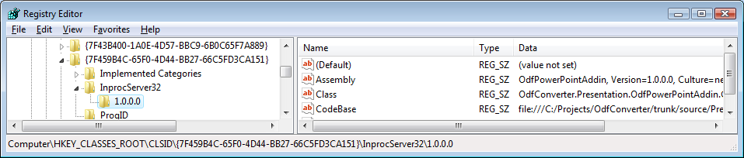

**ONLY ONE VERSION**

#### Add-in Options

Add-in options are stored under the following key when installed “per-user”:

[HKEY_CURRENT_USER\Software\OpenXML-ODF Translator\ODF Add-in for PowerPoint}

When installed “per-machine”

[HKEY_CURRENT_USER\Software\OpenXML-ODF Translator\ODF Add-in for PowerPoint}

[HKEY_LOCAL_MACHINE\Software\OpenXML-ODF Translator\ODF Add-in for PowerPoint}

## Windows Vista complement

Windows Vista brings a new feature to allow old applications to run without privileges: Virtualization

It means that a program running as a simple user can read and **write in forbidden places** in the file system or the registry => Vista virtualizes that in a way that only the programs launched without administrator privileges by the current user see these changes.

If there is once a problem with an add-in (wrong PIAs installed for example), the corresponding Office application will disable the add-in. If the add-in has been installed for “All users”, then this will be a problem **forbidding all subsequent add-in versions to work**:

1. The Add-in is disabled by changing the LoadBehavior value from 3 to 2 under the HKEY_LOCAL_MACHINE\Software\Microsoft\Office*OfficeApplication*\AddIns*AddinName* registry[1] key
2. As the Office application is not running “as an administrator”, the real place where this value is written and then read by the Office application is the **corresponding virtualized key**, i.e. HKEY_CURRENT_USER\Software\Classes\Virtualstore\Machine\Software\Microsoft\Office \OfficeApplication\Addins\AddinName
3. Installations or uninstallation of the add-in are run “as an administrator” and therefore write and remove the “real” registry key (i.e. under HKEY_LOCAL_MACHINE) => uninstalling the add-in and reinstalling it will not change the virtualized value and the Office application will therefore always read the “2” value and therefore will not load the add-in
4. As the add-in is installed as “all users” and not “current user”, the Office application will not display it in its “COM Add-in” dialog box[2] and therefore will not provide a way for the user to re-enable the add-in.

The only way to reactivate the add-in is to launch regedit.exe and **change the virtualized registry value** (as regedit.exe is run “as an administrator”, it will display the real value, i.e. “3” under HKEY_LOCAL_MACHINE) or remove the virtualized key.

## Additional Troubleshooting Steps

### Step 1: Check that only one version of the translator is installed

When the ODF menu entries do not appear, the first thing to do is to check if there is only one version of the translator installed. Uninstall all installed versions via *Control Panel -> Add or Remove Programs* manually and re-install the translator.

### Step 2: Check Office configuration

There are two things to check in the Office application where the ODF menu entries do not appear:

* **Check the Security**

The add-ins installed locally must be allowed to run. Refer to the documentation of the corresponding Office application for the required steps (by default, locally installed add-ins are allowed to run).

* **Check that the add-in is registered and has not been disabled**

During the setup of the Translator, the add-in can be registered either for the current user (i.e. the user running the setup) or for all users of the machine.

With Office 2007, it is possible to check the registration of all add-ins through the user interface. With older versions of Office, only the add-ins registered for the current user can be checked from Office’s user interface: the shared add-ins registration must be checked with regedit.

|  |  |  |
| --- | --- | --- |
| **Tool** | **Target** | **How** |
| **Office 2003 User Interface** | Private add-ins | Customize the menus or tool bars to add the “COM Add-Ins” button and click on the button to display the list of add-ins.  If the add-in is displayed but not activated, try to activate it.  **If the add-in is not displayed, don’t try to add it through Office User interface[3]: deinstall and then reinstall the add-in** |
| **Office 2007 User Interface** | All add-ins | Open the Options dialog box and then the Add-Ins tab. Private add-ins cans be reactivated through the “Manage Com Add-ins” feature but shared add-ins cannot.  **If the add-in is not displayed, don’t try to add it through Office User interface: deinstall and then reinstall the add-in** |
| **Registry** | Private add-ins | Check the HKEY_CURRENT_USER\Software\Microsoft\Office*OfficeApplication*\Addins key.  The add-in should be displayed there and should contain a “LoadBehavior” value equals to 3. If this value is not 3, try to reactivate the add-in by setting it to 3 again. |
| **Registry** | Shared add-ins | Check the HKEY_LOCAL_MACHINE\Software\Microsoft\Office*OfficeApplication*\Addins key.  The add-in should be displayed there and should contain a “LoadBehavior” value equals to 3. If this value is not 3, try to reactivate the add-in by setting it to 3 again. |

Table : Add-in registration tools

Here is a screenshot of Excel 2007 Add-in dialog box with the Translator installed and activated:

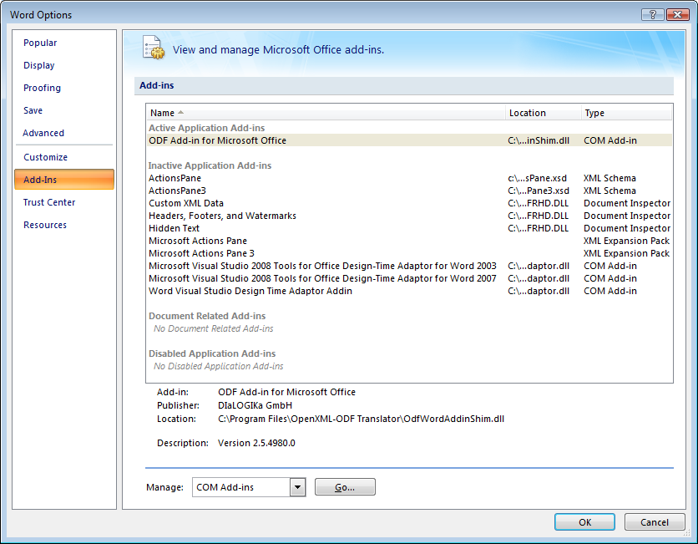

The add-in is installed and enabled

Figure : Excel Add-In list with OpenXML/ODF Translator registered and active

Even if the ODF Add-in for Microsoft Office is registered, it can be inactive. This can result from a manual action of the user or from a missing pre-requisite: If an Office application fails to load an add-in, this add-in will be inactivated.

In the following screenshot, the ODF Add-in for Microsoft Office is registered but deactivated:

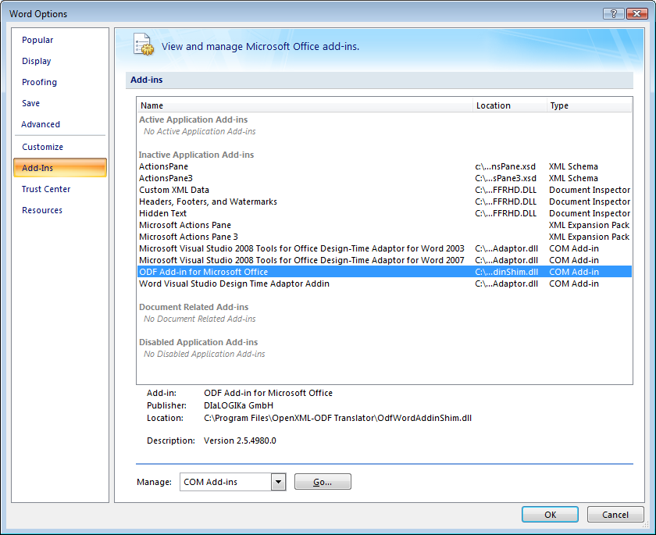

Click here to re-activate the add-in.

Figure : Word Add-In list with OpenXML/ODF Translator registered but inactive

When the “Go…” button is pressed, this window appears[4]:

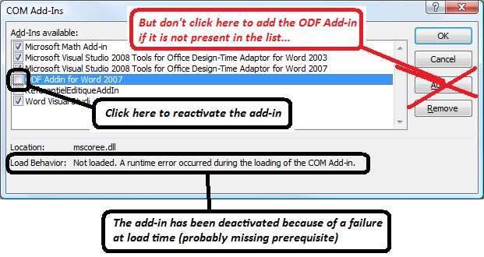

Figure : COM Add-Ins dialog box

If the Add-in has been successfully loaded but generated a crash when converting a document, it will be disabled by Office as shown in the following screenshot:

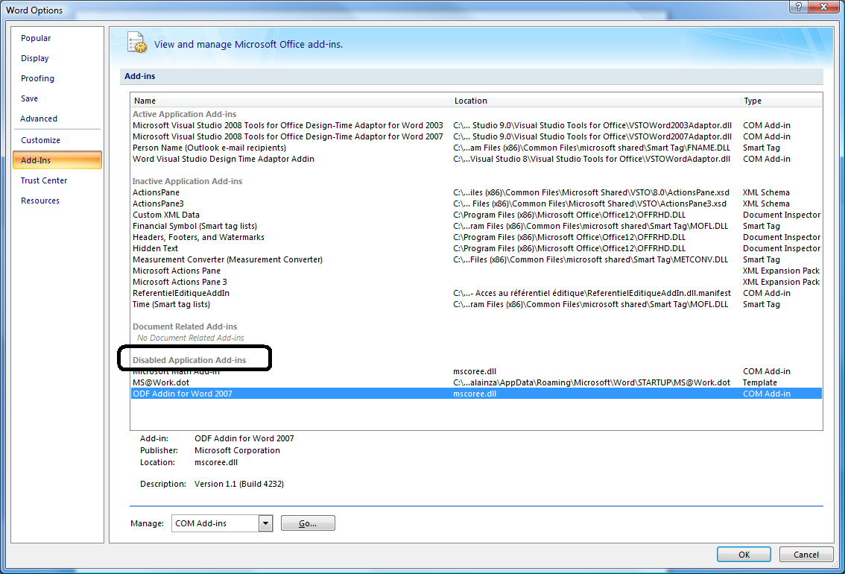

Figure 4: Disabled add-in

In this case, it is possible to re-enable the add-in by first selecting “Disabled Items” in the “Manage” combo box and click on “Go…” button:

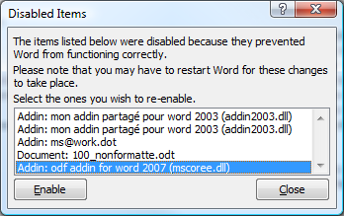

Figure 5: Disabled Items management

|  |  |
| --- | --- |
| **Image1.png** | Windows Vista brings a new feature to allow old applications to run without privileges: Virtualization |
|  | It means that a program running as a simple user can read and **write in forbidden places** in the file system or the registry => Vista virtualizes this kind of operation in a way that the program acts as if it had been able to write in this places (i.e. it reads the values it has written) but does not write in this protected place. All programs without privileges will share this virtualized place while programs launched with administrative rights will access the real values in the registry.  If there is once a problem with an add-in (wrong PIAs installed for example), the corresponding Office application will disable the add-in. If the add-in has been installed for “All users”, then this will be a problem **forbidding all subsequent add-in versions to work**:   1. The Add-in is disabled by changing the LoadBehavior value from 3 to 2 under the HKEY_LOCAL_MACHINE\Software\Microsoft\Office*OfficeApplication*\AddIns*AddinName* registry[5] key 2. As the Office application is not running “as an administrator”, the real place where this value is written and then read by the Office application is the **corresponding virtualized key**, i.e. HKEY_CURRENT_USER\Software\Classes\Virtualstore\Machine\Software\Microsoft\Office \OfficeApplication\Addins\AddinName 3. Installations or un-installation of the add-in which are run “as an administrator” write and remove the “real” registry key (i.e. under HKEY_LOCAL_MACHINE) => uninstalling the add-in and reinstalling it will not change the virtualized value and the Office application will therefore always read the “2” value and therefore will not load the add-in 4. As the add-in is installed as “all users” and not “current user”, the Office application will not display it in its “COM Add-in” dialog box[6] and therefore will not provide a way for the user to re-enable the add-in.   The only way to reactivate the add-in is to launch regedit.exe and **change the virtualized registry value** (as regedit.exe is run “as an administrator”, it will display the real value, i.e. “3” under HKEY_LOCAL_MACHINE) or remove the virtualized key. |

### Step 3: Check that the pre-requisites are installed

The OpenXML/ODF Translator depends on several software components. Some of these components are installed by the Translator installers themselves but not all of them. In addition, they are independent of the Translators and can therefore be uninstalled inadvertently.

The following table shows all pre-requisites for OpenXML/ODF Translators.

|  |  |  |  |  |  |  |  |  |  |  |
| --- | --- | --- | --- | --- | --- | --- | --- | --- | --- | --- |
|  | **Word 2007** | **Word 2003** | **Word XP** | **Word 2000** | **Excel 2007** | **Excel 2003** | **Excel XP** | **Ppt 2007** | **Ppt 2003** | **Ppt XP** |
| **.NET Framework 2.0 SP1** | ✓ | ✓ | ✓ | ✓ | ✓ | ✓ | ✓ | ✓ | ✓ | ✓ |
| **Compatibility pack for the 2007 Office System** |  | ✓ | ✓ | ✓ |  | ✓ | ✓ |  | ✓ | ✓ |
| **KB 908002** |  | ✓ | ✓ |  |  | ✓ | ✓ |  | ✓ | ✓ |

Table : pre-requisite summary

The following paragraphs present details and comments about each of these pre-requisites.

### .NET Framework 2.0 SP1

It must be installed before installing the OpenXML/ODF Translator add-in. Its presence can be checked through the ‘Add/Remove Programs’ Control Panel applet:



Figure : .NET Framework 2.0 Service Pack 1 in Control Panel Applet

|  |  |
| --- | --- |
| **Image1.png** | Vista: .NET Framework 2.0 is part of Windows Vista and therefore does not need to be installed manually and does not appear in Control Panel. |

### 

### Compatibility Pack for the 2007 Office System

The compatibility Pack for the 2007 Office System should be installed by the OpenXML/ODF Translator setup procedure but can be installed independently.

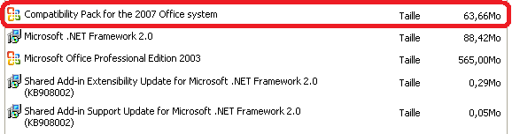

Figure : Compatibility Pack for the 2007 Office System in Control Panel Applet

### KB908002

This pair of updates is needed for Office XP as well as Office 2003 and is installed by the OpenXML/ODF Translator setup if not already present on the computer. Note that there are two entries in the Add-Remove programs applet.

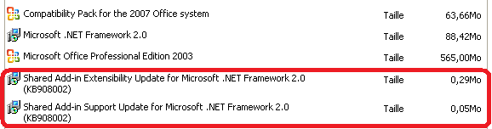

Figure : KB908002 updates in Control Panel Applet

Under particular and rare conditions, these entries can be present but the corresponding updates not correctly installed for the current user; in this situation, it can be useful to reinstall these updates. In this case, uninstall the Translator as well as these updates through the control panel and reinstall manually these updates before reinstalling the Translator:

1. Extract the content of the setup package by using the options /C and /T on the command line as described in the section on silent installation above.
2. Install **extensibilityMSM.msi** and **lockbackRegKey.msi**
3. Then Install the add-in.

1. Where OfficeApplication is either Word, Excel or Powerpoint and AddinName is the COM name of the add-in such as OdfWordXPAddin.Connect or OdfExcel2007Addin.Connect.
2. Office 2007 applications will display such add-ins but it will not solve the problem as they don’t allow the user to change the setup of these add-ins.
3. The ODF Converter Add-ins are not standard COM Objects which are the only kind of add-ins that can be re-registered through Office user interface. Therefore an error message will be displayed if the user tries to register the ODF Converter add-ins from an Office application.
4. Older versions of Office display directly this dialog box.
5. Where OfficeApplication is either Word, Excel or Powerpoint and AddinName is the COM name of the add-in such as OdfWordXPAddin.Connect or OdfExcel2007Addin.Connect.
6. Office 2007 applications will display such add-ins but it will not solve the problem as they don’t allow the user to change the setup of these add-ins.